|  |  |  |  |
| --- | --- | --- | --- |
| \\lyng-dc1\StaffShared\Learning Bugs Animals ALL subjects\characters bugs animals\Cyril the Snail - History.jpeg**Lyng Primary School Knowledge Organiser**  **History** | | | |
| **History Topic: All About Me** | **What makes me, me?**  **How has my town changed?** | Year 1 | Autumn 1 |



|  |  |
| --- | --- |
| **What Step On and Goldilocks words will I use?** | |
| **Spelling** | **Definition** |
| chronological | If things are described or shown in chronological order, they are described or shown in the order in which they happened. |
| present | If things are described or shown in chronological order, they are described or shown in the order in which they happened. |
| past | The past is the time before the present, and the things that have happened. |
| future | The future is the period of time that will come after the present, or the things that will happen then. |
| information | Information about someone or something consists of facts about them. |
|  |  |

**Background information for parents and teachers**

Children will look in depth at their family history,

where they were born and where they now live. We will share photographs of children in their birth countries and share experiences.

We will also take a close look at West Bromwich town in the po

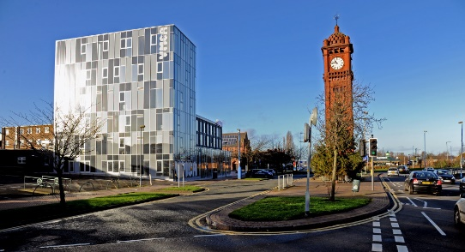

|  |
| --- |
| **When?** |

This topic focuses on recent family history and recent West Bromwich history.

Long ago, before there were big towns and cities, West Bromwich was just a small village surrounded by fields and forests. People lived simple lives, farming the land and trading goods.

As time passed, more people came to live in West Bromwich. They built houses, shops, and markets, and the village grew into a bustling town.

During the Industrial Revolution, which happened in the 18th century, West Bromwich became even busier. Factories were built, and the town became famous for making things like iron and steel.

Over the years, West Bromwich continued to grow and change. Schools, churches, and parks were built to serve the growing population. Today, West Bromwich is a vibrant town with a rich history, where people from all walks of life live, work, and play together.

Lyng Primary school was formed in January 1981 by Lyttleton Hall Infant School and Lyng Junior School. A Nursery was opened in October 1990.

**TRIP/VISITOR**

Local area walk. Explore the significant aspects of West Bromwich.

**Hook**

Using old family photos, children guess who the photograph is of.

**Great Quotes**

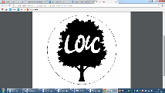

Diversity is not about how we are differ. Diversity is about embracing one another’s uniqueness.

Ola Joseph

**Our Storytelling Approach to enhance engagement**

|  |  |  |
| --- | --- | --- |
| **People:**  Jesse Boot | **Place:**  West Bromwich | **Problem:**  What did West Bromwich town need in the year 1850? |

**Key Questions**

**Key People**

**Jesse Boot, 1st Baron Trent**:

Jesse Boot, the founder of Boots UK, the well-known pharmacy chain, was born in West Bromwich in 1850. While he later moved to Nottingham to expand his business, his upbringing in West Bromwich influenced his entrepreneurial spirit and commitment to public health.

What was West Bromwich like in 1850 when Jesse Boot was born?

In 1850, West Bromwich was a busy town full of factories and workshops. People worked hard making things like iron, steel, and clothes. The town was growing, and lots of families moved there to find jobs and start new lives.

Busy Factories: West Bromwich was known for its big factories where people made all sorts of things. These factories were like giant workshops buzzing with activity.

Growing Town: More and more people were coming to live in West Bromwich, so the town was getting bigger. New houses and neighbourhoods were popping up to fit everyone.

Noisy and Crowded: The streets of West Bromwich were bustling with people, horses, and carts. It was loud and crowded, with lots of things happening all the time.

Building Bridges and Roads: Workers were busy building new roads and bridges to connect West Bromwich to other towns and cities nearby. This made it easier for people and goods to travel around.

Fun and Entertainment: Even though life could be tough, people in West Bromwich still found ways to have fun. They went to theatres to watch plays, listened to music, and enjoyed spending time with friends and family.

* How has West Bromwich changed?
* Where was I born?
* What did I look like when I was 3 years old?
* What year was I born in?

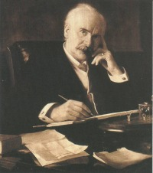

**Agreed Outcome**

Children can use the vocabulary past and present confidently.